Lab Assignment 9.3
Task 1: Write python function to return sum of even and odd numbers in the given list
Gemini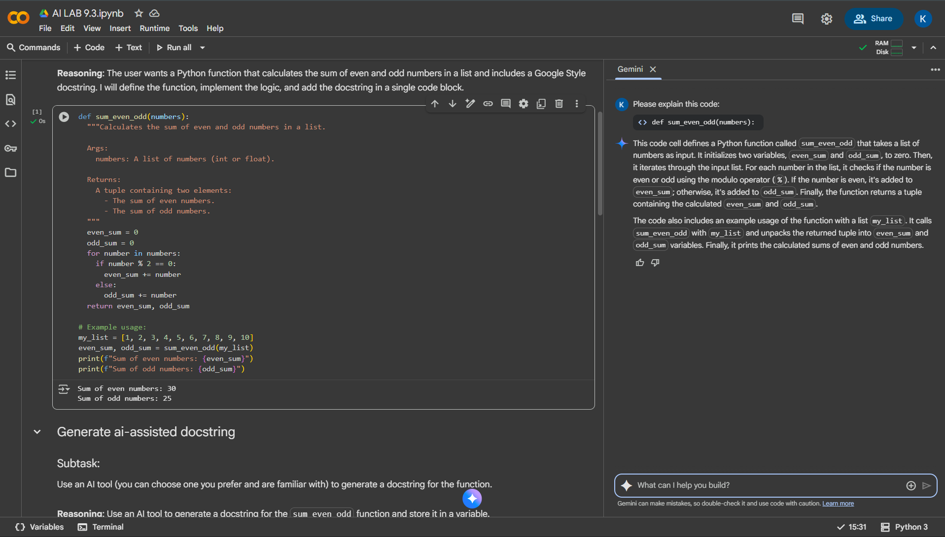
GitHub Co-pilot
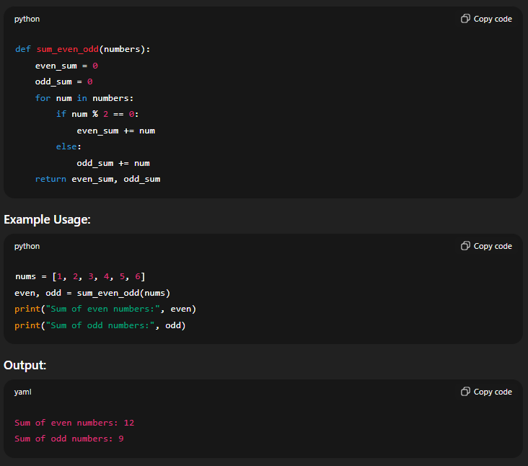
Task 2: Write python program for sru_student class with attributes like name, roll no., hostel_status and fee_update method and display_details method
Gemini
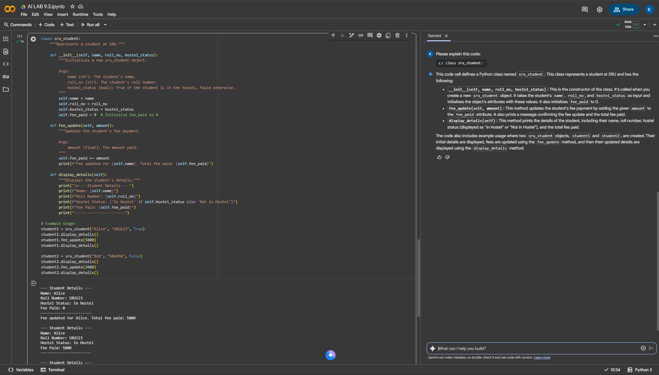

GitHub Co-pilot
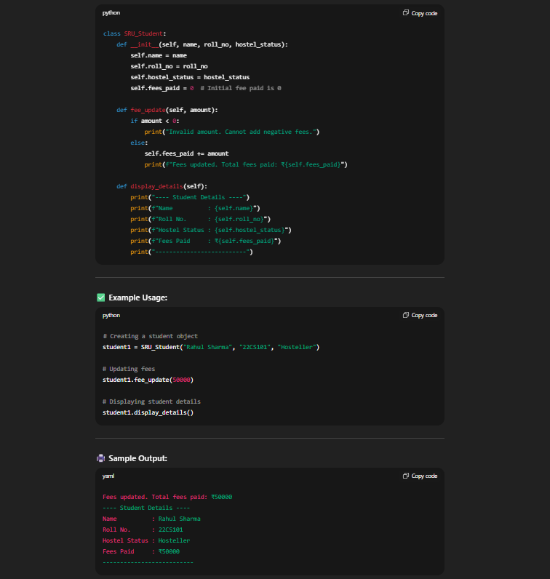

Task 3: Write a Python script with 3–4 functions (e.g., calculator: add, subtract, multiply, divide).
Gemini
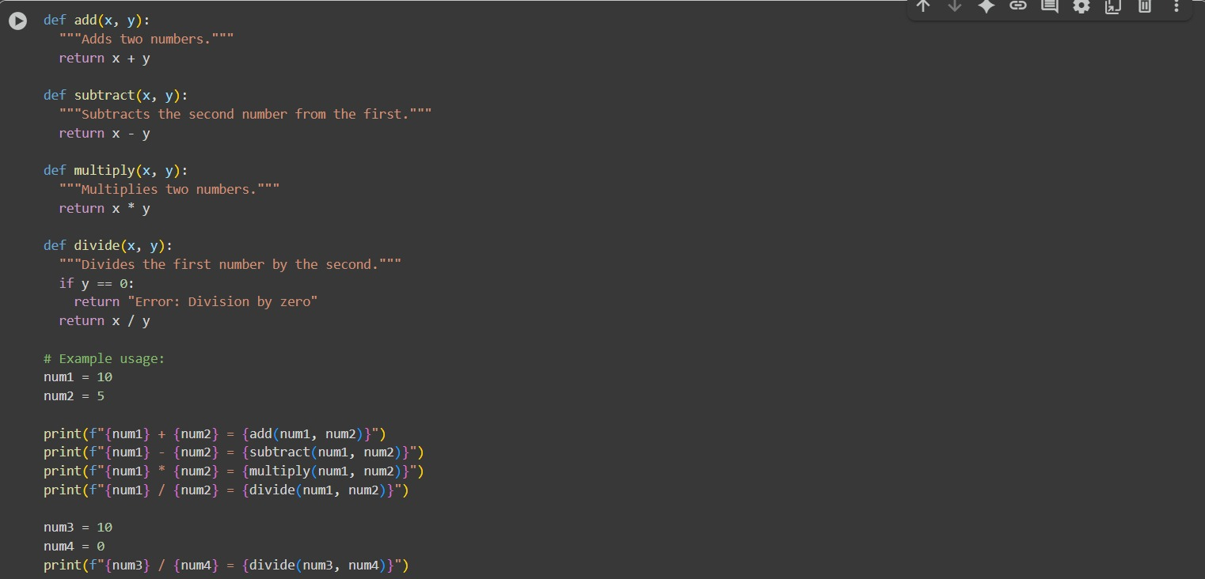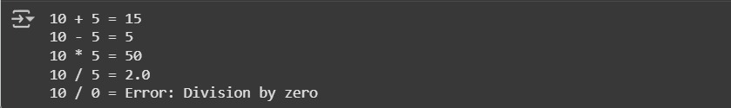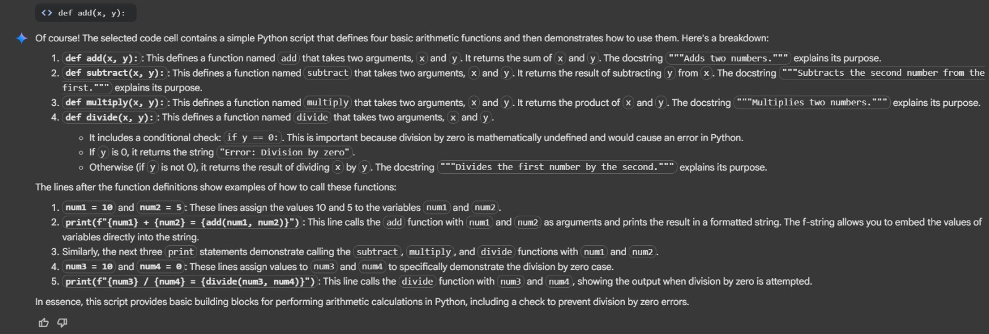

GitHub Co-pilot
